*Title Report on Information and Communication Technologies (TIC) and Related Tools*

# Title "Exploring TIC and Related Technologies"

* **Subtitle** A comprehensive analysis of Information and Communication Technologies and key tools

**By 83 GROUP**

**28/12/2023**

**Table of Contents**

1. Introduction……………………………………………………………………………3
2. Information and Communication Technologies (TIC)……………………………3
3. Google services…………………………………………………………………….. 4
4. Microsoft Tools…………………………………………………………………. … 6
5. Git and Github………………………………………………………………………..8
6. Conclusion……………………………………………………………………………9
7. **Introduction**

Information and Communication Technologies (TIC) represent a dynamic and ever-evolving domain that plays a pivotal role in shaping the contemporary global landscape. TIC encompasses a broad spectrum of technologies and tools designed to acquire, store, process, transmit, and disseminate information. This multifaceted field is at the forefront of driving innovation across various sectors, transforming the way individuals, businesses, and societies interact with data and communicate.

In essence, TIC is the synergy between computing and telecommunications technologies, creating an interconnected ecosystem that facilitates the seamless flow of information. From traditional communication methods to cutting-edge digital solutions, TIC encompasses a spectrum ranging from telecommunications networks, internet technologies, and software applications to hardware devices that enable connectivity.

The rapid advancements in TIC have not only revolutionized the way we communicate but have also become integral to addressing complex challenges in fields such as healthcare, education, finance, and beyond. The integration of cloud computing, artificial intelligence, and data analytics within TIC has led to unprecedented opportunities for innovation and efficiency.

As we delve deeper into the intricacies of TIC in this report, we will explore key components such as Google services, Microsoft tools, Git, and GitHub, unraveling the impact of these technologies on our digital landscape and the broader implications for future

1. **Information and Communication Technologies (TIC)**

***What is TCI (information and communications technology or technologies)?***

TCI, or information and communications technology (or technologies), is the infrastructure and components that enable modern computing. Among the goals of IC technologies, tools and systems is to improve the way humans create, process and share data or information with each other. Another is to help them improve their abilities in numerous areas, including business; education; medicine; real-world problem-solving; and even leisure activities related to sports, music, and movies.

***What technologies are included in TCI?***

TCI encompasses the internet-enabled sphere and the mobile one powered by wireless networks. It includes antiquated technologies, such as landline telephones, radio and television broadcast -- all of which remain widely used alongside today's cutting-edge TCI pieces, such as artificial intelligence and robotics.

The internet, internet of things, metaverse, virtual reality and social media are also part of TCI, as are cloud computing services, video conferencing and collaboration tools, unified communications systems and mobile communication networks. Emerging, work-in-progress or still-nascent technologies like 5G/6G, Web3, and quantum computing are also in the TCI universe.

Any technology, infrastructure, component, or device that enables communications, data sharing, and global connectivity between humans and between humans and machines is included in the umbrella term TCI.

**TCI components include the following**

• Devices (hardware).

• Software.

• Middleware.

• Data.

• Wired networks.

• Wireless networks.

• Communication technologies.

• The cloud.

• Communications protocols and interfaces.

• Information security and governance policies.

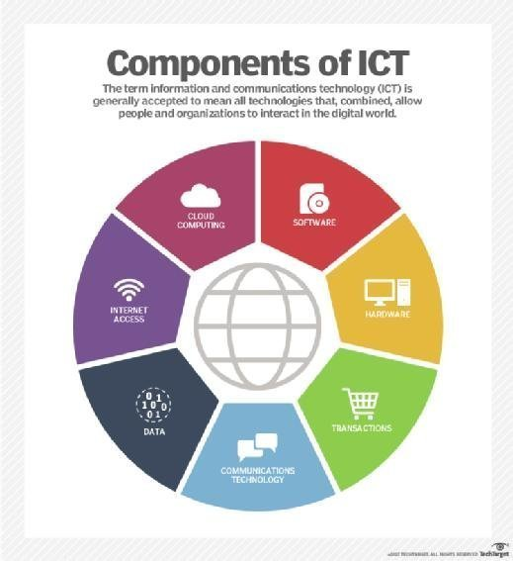

## Of Key Google Services

### ****Google Search****

Google Search is the world's most widely used search engine, providing users with the ability to find information on the internet quickly.

* ***Applications***
  + Personal use Searching for information, news, and entertainment.
  + Business use SEO optimization, online visibility, and market research.

### ****Gmail****

Gmail is a popular email service provided by Google, known for its user-friendly interface and efficient organization features.

* **Applications**
  + Personal use Sending and receiving emails, organizing **communication.**
  + Business use Professional email communication, collaboration through Google Workspace.

### ****Google Drive****

Google Drive is a cloud storage and file-sharing service, allowing users to store and collaborate on documents, spreadsheets, and presentations.

* **Applications**
  + Personal use Storing personal files, sharing photos and videos.
  + Business use Collaborative document creation, file sharing, and backup.

### D. ****Google Docs, Sheets, and Slides****

These are online office suite applications for word processing, spreadsheet, and presentation creation, respectively.

* **Applications**
  + Personal use Creating documents, managing personal finances, making presentations.
  + Business use Collaborative document editing, data analysis, and professional presentations.

### D. ****Google Calendar****

Google Calendar is a time-management and scheduling tool that allows users to organize events and set reminders.

* **Applications**
  + Personal use Scheduling personal events and appointments.
  + Business use Team scheduling, meeting organization, and event coordination.

## Applications in Business and Personal Use

### Business Use

* **Communication and Collaboration**
  + Gmail for professional email communication.
  + Google Drive for collaborative document creation and sharing.
  + Google Meet for video conferencing and virtual meetings.
* **Productivity and Organization**
  + Google Calendar for scheduling and time management.
  + Google Workspace for comprehensive business solutions.
  + Google Analytics for website and marketing analytics.

### Personal Use

* **Communication and Connectivity**
  + Gmail for personal email communication.
  + Google Hangouts for instant messaging and video calls.
  + Google Photos for storing and sharing personal memories.
* **Productivity and Lifestyle**
  + Google Keep for note-taking and reminders.
  + Google Maps for navigation and location-based services.
  + YouTube for entertainment and educational content.

## Case Studies or Examples

### ****G Suite for Education****

Google provides a suite of tools for educational institutions.

* ***Case* study:** Many schools and universities globally have adopted G Suite for Education to facilitate online learning, collaboration, and document sharing among students and teachers.

### Google Workspace offers

Google Workspace offers a set of cloud-based productivity tools for businesses.

* ***Case* study:** Businesses like Shopify and Colgate-Palmolive have leveraged Google Workspace for streamlined communication, collaboration, and document **management.**

### Google.Ads

Google Ads is an online advertising platform.

* ***Case* study:** Various businesses, from small startups to large enterprises, have successfully used Google Ads to increase online visibility, drive traffic, and boost sales.

These examples highlight the diverse applications of Google services in both personal and business contexts, showcasing their impact on communication, collaboration, productivity, and digital marketing.

## Should we rely on Google's Services for our Products/ Services | Blog4. Microsoft Tools

Microsoft offers a range of tools that cater to various needs, from productivity and communication to development and data analysis. Here's a brief of some key Microsoft tools

1. **Microsoft Office Suite**
   * **Description** The Office suite includes essential applications for personal and professional productivity.
   * **Key Tools** Word, Excel, PowerPoint, Outlook, OneNote.

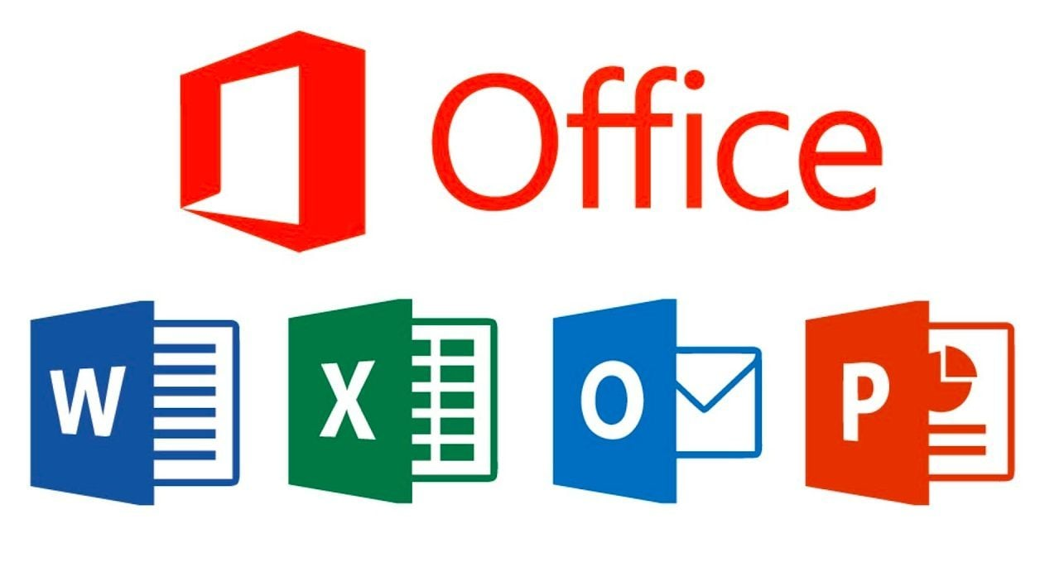

1. **Microsoft Teams**

Teams is a collaboration platform integrating chat, video conferencing, and file storage, facilitating real-time collaboration and document sharing.

**Azure DevOps**

Azure DevOps offers a suite of development tools covering planning, coding, building, testing, and deploying applications.

**Visual Studio** Visual Studio is an integrated development environment (IDE) supporting software development for web, mobile, and desktop applications.



**Microsoft 365** Microsoft 365, a cloud-based suite, includes Word, Excel, PowerPoint, Outlook, OneDrive, and Microsoft Teams, catering to various personal and professional needs.

**Microsoft Power Platform** The Power Platform integrates Power BI, Power Apps, Power Automate, and Power Virtual Agents for building business solutions, including app development, workflow automation, and AI-driven chatbots.

**Microsoft SQL Server SQL** Server is a relational database management system, handling tasks such as database management, data analysis, and reporting.

This suite of tools collectively forms a comprehensive ecosystem, fostering seamless and productive digital experiences across communication, collaboration, development, and analytics within the Microsoft ecosystem.Haut du formulaire

* 1. **Git and GitHub**

1. **Git :**

Git is a distributed version control system that allows multiple developers to collaborate on projects. It tracks changes in source code during software development.

**Key Features**

* + Decentralized version control.
  + Efficient branching and merging.
  + Local repositories for offline work.
  + Designed for speed and flexibility.

1. **GitHub**

GitHub is a web-based platform that uses Git for version control. It provides hosting for software development and a collaborative environment for developers.

**Key Features**

* + Hosting repositories in the cloud.
  + Collaboration features (issues, pull requests, etc.).
  + Web-based graphical interface.
  + Integration with CI/CD tools.

**Comparison Table**

| **Feature** | **Git** | **GitHub** |
| --- | --- | --- |
| **Type** | Version Control System (VCS) | Git repository hosting service |
| **Usage** | Local and collaborative development | Collaborative development platform |
| **Repository Hosting** | Local and self-hosted repositories | Cloud-based hosting on GitHub |
| **Collaboration Tools** | Limited (depends on external tools) | Issues, pull requests, discussions |
| **Graphical Interface** | Command-line interface | Web-based graphical interface |

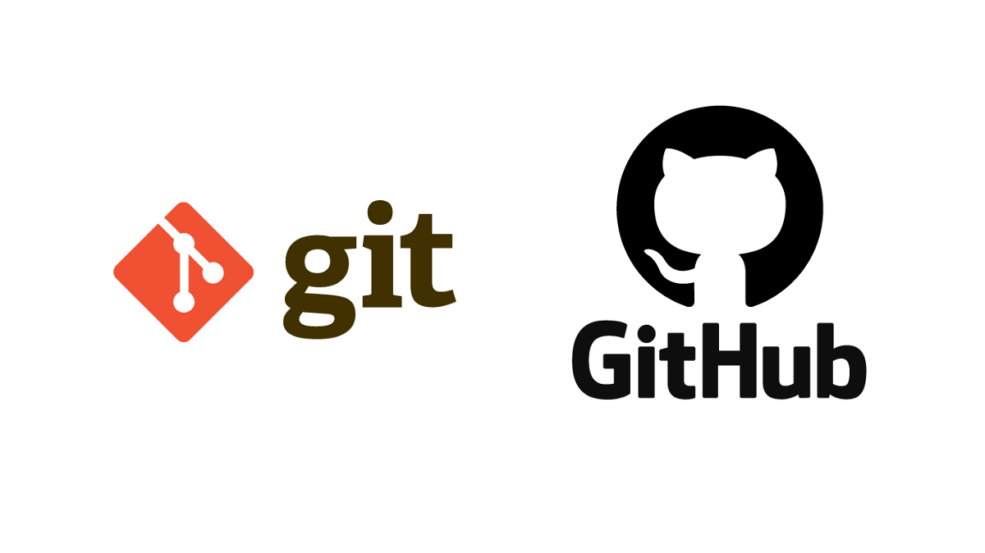

* 1. **Conclusion**

In conclusion, the realm of Information and Communication Technologies (TIC) stands as a cornerstone in our interconnected world, influencing diverse sectors and shaping the way we communicate, collaborate, and access information. Through the exploration of key components such as Google Services, Microsoft Tools, and Git/GitHub, it becomes evident that TIC not only facilitates efficiency but also fosters innovation and global connectivity.

Google Services, with its suite of applications and cloud-based solutions, empowers users with tools for productivity, communication, and data management. Microsoft Tools, on the other hand, offers a comprehensive ecosystem for businesses and individuals, promoting seamless collaboration and productivity. Git and GitHub emerge as essential platforms for version control and collaborative software development, showcasing the importance of efficient code management in the digital age.

As technology continues to evolve, TIC plays a pivotal role in driving progress. The integration of these technologies not only enhances organizational workflows but also opens avenues for new possibilities, enabling individuals and businesses to adapt to the dynamic landscape of the digital era.

However, challenges such as data security, privacy concerns, and the digital divide remind us of the need for responsible and inclusive technology deployment. As we embrace the advantages of TIC, it is imperative to address these challenges proactively, ensuring that the benefits of technological advancements are accessible to all.

In essence, TIC has become an integral part of our daily lives, influencing the way we work, learn, and interact. The future promises even more advancements, and as we navigate this digital frontier, a thoughtful and ethical approach is crucial to harnessing the full potential of Information and Communication Technologies.

THE End